# **Project 1: DSP**

**RTL Code:**

**Testbench Code:**

**Do file:**

**QuestaSim Snippets:**

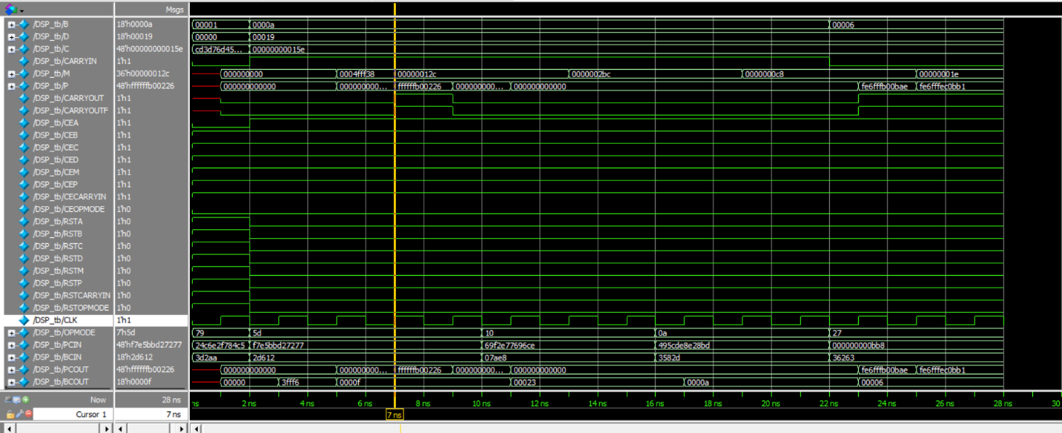

**Constraint File:**

**Elaboration :**

Messages” tab & Schematic snippets:

**Synthesis:**

Messages tab & Schematic snippets:

Utilization report:

timing report:

**Implementation:**

Messages tab:

timing report & device snippets:

Utilization report:

Linting (snippets showing no errors)

Note: these are the names I used if they are not clear

